## Exercise 1.18.5: Managing Change

Here is the homepage for a baseball fan’s website about baseball. As you can see, she is struggling to get the styling just right.

Right now, the site looks like this:



### Task One

Can you find and remove a repeated rule that causes the button’s backgrounds to blend into each other? There is an entire rule that is unnecessary.

When you’re done, the site should look like this:



Did you get rid of the repeated rule? Thanks! The buttons look much better now.

Only…. now the designer is thinking that she really doesn’t like the color scheme.

What she really wants is something like this:

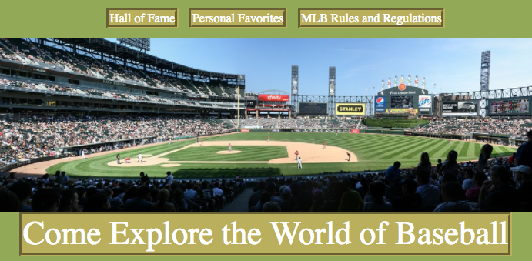

She wants the buttons’ text to be white and their backgrounds to be #baaf5d.

She also thinks she could use some help applying the DRY principle.

### Task Two

Can you condense the rules so that the buttons’ font color and background color are only specified in **exactly one** rule? You won’t have to change any of the other styles – **just the font color and background color**.